Chapter 1: Introduction

1.1 What is COCOMO?
COCOMO (Constructive Cost Model) is a screen-oriented, interactive software package that assists in budgetary planning and schedule estimation of a software development project. Through the flexibility of COCOMO, a software project manager (or team leader) can develop a model (or multiple models) of projects in order to identify potential problems in resources, personnel, budgets, and schedules both before and while the potential software package is being developed.
The COCOMO software package is based upon the software cost and schedule estimation model: Constructive Cost Model version II (COCOMOII). This is the newly revised version of the original Constructive Cost Model (COCOMO) first published by Dr. Barry Boehm in his book Software Engineering Economics, Prentice-Hall (1981), and Ada COCOMO (1989) predecessors. The current model is described in [Boehm et al. 1995]
The primary objectives of the COCOMOII.1998 effort are
■ To develop a software cost and schedule estimation model tuned to the life cycle practices of the 1990's and 2000's.
■ To develop software cost database and tool support capabilities for continuous model improvement.
■ To provide a quantitative analytic framework and set of tools and techniques for evaluating the effects of software technology improvements on software life cycle costs and schedules.
The full COCOMOII model includes three stages. Stage 1 supports estimation of prototyping or applications composition efforts. Stage 2 supports estimation in the Early Design stage of a project, when less is known about the project’s cost drivers. Stage 3 supports estimation in the Post-Architecture stage of a project.
This version of USC COCOMOII implements stage 3 formulas to estimate the effort, schedule, and cost required to develop a software product. It also provides the breakdown of effort and schedule into software life-cycle phases and activities from the original COCOMO manual. These are still reasonably valid for waterfall model software projects but need to be interpreted for non-waterfall projects.

Effort Estimation Equation
(EQ 1-1)

Estimate effort with:
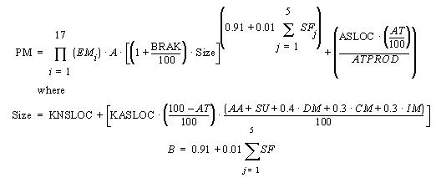

Symbol | Description
A | Constant, currently calibrated as 2.45
AA | Assessment and assimilation
ADAPT | Percentage of components adapted (represents the effort required in understanding software)
AT | Percentage of components that are automatically translated
ATPROD | Automatic translation productivity
BRAK | Breakage: Percentage of code thrown away due to requirements volatility
CM | Percentage of code modified
DM | Percentage of design modified
EM | Effort Multipliers: RELY, DATA, CPLX, RUSE, DOCU, TIME, STOR, PVOL, ACAP, PCAP, PCON, AEXP, PEXP, LTEX, TOOL, SITE
IM | Percentage of integration and test modified
KASLOC | Size of the adapted component expressed in thousands of adapted source lines of code
KNSLOC | Size of component expressed in thousands of new source lines of code
PM | Person Months of estimated effort
SF | Scale Factors: PREC, FLEX, RESL, TEAM, PMAT
SU | Software understanding (zero if DM = 0 and CM = 0)

1.1.2 Schedule Estimation Equation
Determine time to develop (TDEV) with an estimated effort, PM, that excludes the effect of the SCED effort multiplier:
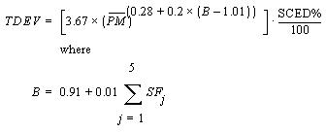
(EQ 1-2)

Symbol | Description
PM | Person Months of estimated effort from Early Design or Post-Architecture models (excluding the effect of the SCED effort multiplier).
SF | Scale Factors: PREC, FLEX, RESL, TEAM, PMAT
TDEV | Time to develop
SCED | Schedule
SCED% | The compression / expansion percentage in the SCED effort multiplier

1.1.3 Scale Factors
Equation 1-2 defines the exponent, B, used in Equation 1-1. Table 1.1 provides the rating levels for the COCOMOII scale drivers. The selection of scale drivers is based on the rationale that they are a significant source of exponential variation on a project’s effort or productivity variation. Each scale driver has a range of rating levels, from Very Low to Extra High. Each rating level has a weight, W, and the specific value of the weight is called a scale factor. A project's scale factors, W_{i}, are summed across all of the factors, and used to determine a scale exponent, B, via the following formula:

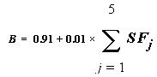
(EQ 1-3)

For example, if scale factors with an Extra High rating are each assigned a weight of (0), then a 100 KSLOC project with Extra High ratings for all factors will have SF_{j} = 0, B = 1.01, and a relative effort E = 100^{1.01} = 105 PM. If scale factors with Very Low rating are each assigned a weight of (5), then a project with Very Low (5) ratings for all factors will have SF_{j} = 5, B = 1.26, and a relative effort E = 331 PM. This represents a large variation, but the increase involved in a one-unit change in one of the factors is only about 4.7%.

Scale Factors (SF_{j}) | Very Low | Low | Nominal | High | Very High | Extra High
PREC | thoroughly unprecedented | largely unprecedented | Somewhat unprecedented | generally familiar | largely familiar | thoroughly familiar
FLEX | rigorous | occasional relaxation | some  relaxation | general  conformity | some  conformity | general goals
RESL | little (20%) | some (40%) | often (60%) | Generally (75%) | mostly (90%) | full (100%)
TEAM | very difficult interactions | some difficult interactions | Basically, cooperative interactions | largely  cooperative | highly  cooperative | seamless  interactions
PMAT | Weighted average of “Yes” answers to CMM Maturity Questionnaire
Table 1.1: Scale Factors for COCOMO.II Early Design and Post-Architecture Models

1.1.4 Sizing Methods
SLOC: Lines of Code Counting Rules
In COCOMOII, the logical source statement has been chosen as the standard line of code. Defining a line of code is difficult due to conceptual differences involved in accounting for executable statements and data declarations in different languages. The goal is to measure the amount of intellectual work put into program development, but difficulties arise when trying to define consistent measures across different languages. Breakage due to change of requirements also complicates sizing. To minimize these problems, the Software Engineering Institute (SEI) definition checklist for a logical source statement is used in defining the line of code measure. The Software Engineering Institute (SEI) has developed this checklist as part of a system of definition checklists, report forms and supplemental forms to support measurement definitions [Park 1992] [Goethert et al. 1992].

Figure 1-1 shows a portion of the definition checklist as it is being applied to support the development of the COCOMOII model. Each checkmark in the “Includes” column identifies a particular statement type or attribute included in the definition, and vice-versa for the excludes. Other sections in the definition clarify statement attributes for usage, delivery, functionality, replications and development status. There are also clarifications for language specific statements for ADA, C, C++, CMS-2, COBOL, FORTRAN, JOVIAL and Pascal.
Some changes were made to the line-of-code definition that departs from the default definition provided in [Park 1992]. These changes eliminate categories of software, which are generally small sources of project effort. Not included in the definition are commercial-off-the-shelf software (COTS), government-furnished software (GFS), other products, language support libraries and operating systems, or other commercial libraries. Code generated with source code generators is not included though measurements will be taken with and without generated code to support analysis.
The “COCOMOII line-of-code definition” can be calculated in several ways. One way is to use the software program, Amadeus [Amadeus 1994] [Selby et al. 1991]. Another software program is code count.

Figure 1-1 Definition Checklist for Source Statements Counts

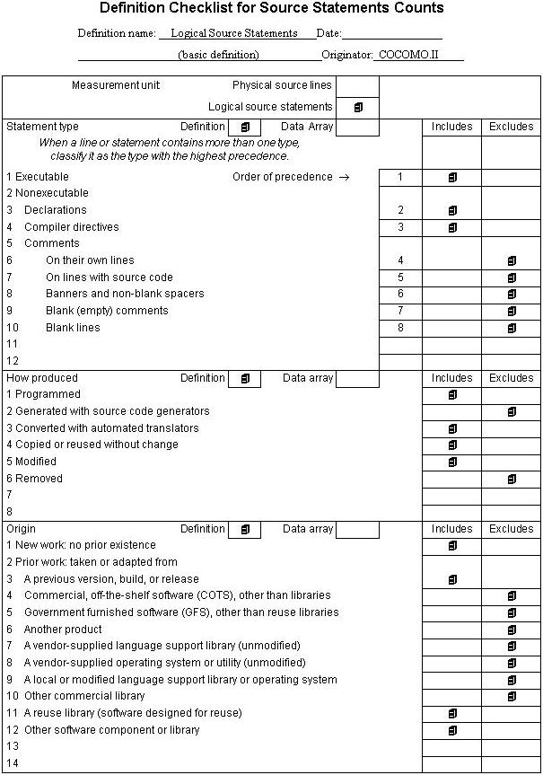

1.1.5 FP: Counting with Unadjusted Function Points
The function point cost estimation approach is based on the amount of functionality in a software project and a set of individual project factors [Behrens 1983][Kunkler 1985][IFPUG 1994]. Function points are useful estimators since they are based on information that is available early in the project life cycle. A brief summary of function points and their calculation in COCOMOII is as follows.
Function points measure a software project by quantifying the information processing functionality associated with major external data input, output, or file types. Five user function types should be identified as defined in the Table2.

External Input (Inputs) | Count each unique user data or user control input type that (i) enters the external boundary of the software system being measured and (ii) adds or changes data in a logical internal file.
External Output (Outputs) | Count each unique user data or control output type that leaves the external boundary of the software system being measured.
Internal Logical File (Files) | Count each major logical group of user data or control information in the software system as a logical internal file type. Include each logical file (e.g., each logical group of data) that is generated, used, or maintained by the software system.
External Interface Files (Interfaces) | Files passed or shared between software systems should be counted as external interface file types within each system.
External Inquiry (Queries) | Count each unique input-output combination, where an input causes and generates an immediate output, as an external inquiry type.
Table 2: User Function Types

Each instance of these function types is then classified by complexity level. The complexity levels determine a set of weights, which are applied to their corresponding function counts to determine the Unadjusted Function Points quantity. This is the Function Point sizing metric used by COCOMII. The usual Function Point procedure involves assessing the degree of influence (DI) of fourteen application characteristics on the software project determined according to a rating scale of 0.0 to 0.05 for each characteristic. The 14 ratings are added together, and added to a base level of 0.65 to produce a general characteristics adjustment factor that ranges from 0.65 to 1.35.
Each of these fourteen characteristics, such as distributed functions, performance, and reusability, thus have a maximum of 5% contribution to estimated effort. This is inconsistent with COCOMO experience; thus COCOMO.II uses Unadjusted Function Points for sizing, and applies its reuse factors, cost driver effort multipliers, and exponent scale factors to this sizing quantity.

1.1.6 AAF: Adaptation Adjustment Factors
Adaptation of Existing Code
COCOMO is not only capable of estimating the cost and schedule for a development started from "scratch", but it is also able to estimate the cost and schedule for products that are built upon already existing code. Adaptation considerations have also been incorporated into COCOMO, where an estimate for KSLOC will be calculated. This value will be substituted in place of the SLOC found in the equations already discussed. This adaptation of code utilizes an additional set of equations that are used to calculate the final count on source instructions and related cost and schedule. These equations use the following values as components:
■ Adapted Source Lines of Code (ASLOC). The number of source lines of code adapted from existing software used in developing the new product.
■ Percent of Design Modification (DM). The percentage of the adapted software’s design that received modification to fulfill the objectives and environment of the new product.
■ Percent of Code Modification (CM). The percentage of the adapted software’s code that receives modification to fulfill the objectives and environment of the new product.
■ Percent of Integration Required for Modified Software (IM). The percentage of effort needed for integrating and testing of the adapted software in order to combine it into the new product.
■ Percentage of reuse effort due to Software Understanding (SU).
■ Percentage of reuse effort due to Assessment and Assimilation (AA).
■ Programmer Unfamiliarity with Software (UNFM)
These components are brought together in Figure 1-6. The AAF is the adaptation adjustment factor. The AAF is the calculated degree to which the adapted software will affect overall development.

1.1.7 Effort Multipliers
There are a number of contributing factors to a project’s delivery time and effort. Development productivity was found to be affected by additional factors that were found to fall under the headings: product attributes, platform attributes, personnel attributes, and project attributes.
Product attributes refer to the constraints and requirements placed upon the project to be developed. These included
■ Required software reliability (RELY)
■ Database size (DATA)
■ Documentation match to life-cycle needs (DOCU)
■ Product complexity (CPLX)
■ Required Reusability (RUSE)
Platform attributes refer to the limitations placed upon development effort by the hardware and operating system being used to run the project. These limitations are listed below.
■ Execution time constraint (TIME)
■ Main storage constraint (STOR)
■ Platform volatility (PVOL)
Personnel attributes refer to the level of skills that are possessed by the personnel. The skills in question are general professional ability, programming ability, experience with the development environment and familiarity with the project’s domain. These skills are characterized below.
■ Analyst capabilities (ACAP)
■ Applications experience (AEXP)
■ Programmer capabilities (PCAP)
■ Platform experience (PEXP)
■ Programming language experience (LEXP)
■ Personnel Continuity (PCON)
Project attributes refer to the constraints and conditions under which project development takes place. The issues that affect development are:
■ Use of software tools (TOOL)
■ Multisite Development (SITE)
These 16 factors are incorporated into calculating an estimated effort and schedule. Each of the factors has associated with it up to six ratings. These ratings are very low, low, nominal, high, very high, and extra high. Each rating has a corresponding real number based upon the factor and the degree to which the factor can influence productivity. A rating less than 1 denotes a factor that can decrease the schedule and effort. A rating greater than 1 denotes a factor that extends the schedule or effort. Lastly, a rating equal to 1 does not extend nor decrease the schedule and effort (this rating is called nominal).
These 16 factors (or effort multipliers) are incorporated into the schedule and effort estimation formulas by multiplying them together (see Figure 1-7 for the COCOMO dialog box). The numerical value of the i^{th} adjustment factor (there are 16 of them) is called EM_{i} and their product is called the adjustment factor or EAF. The actual effort, PM_{total} is the product of the nominal effort times the EAF.
In addition to the 16 EAF factors there are two user defined factors named USR1 and USR2. Their initial values are all set to 1. They may be redefined by using the Parameters-User Defined EAF menu item.
A final effort multiplier, Required Development Schedule (SCED) is treated separately as it operates at the overall project level rather than potentially varying from module to module.

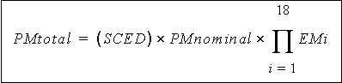
FIGURE 1-2 Estimate Development Effort

1.2 Navigating COCOMO
This software is a stand-alone software system intended for a single user. The software is user interactive in that it attempts to interface well with a user's needs, using extensive mouse interaction wherever possible.
On the screen in Figure 1-3 is the CLEF (Component Level Estimation Form). This is where all of the entered information will be displayed. The top of the screen shows all of the subfunctions which the user may call. The choices appear in pop down menus according to the major headings of Project, Model, and Phase.
In order to efficiently use COCOMO, you must become familiar with the Component Level Estimating Form (CLEF). The different sections that are to be discussed have been given a corresponding number. These sections are given a descriptive label as a point of reference as well as a summary of their contents and functions.
The sections found in Figure 1-3 and their descriptions are as follows:
1. Main Menu bar - This area contains the menu selection of the main functions of COCOMO. These selections are File, View, Edit, Parameters, Calibrate, Phase Distribution and Help. File, View, Edit, Parameters, Calibrate, and Phase Distribution are discussed in chapters 2, 3, 4, 5, and 6 respectively. Help is the selection used to receive on-line assistance with the available functions.
2. Tool bar - This area contains image buttons like other windows applications for New Project, Open Project, Save Project, Delete Module, Copy & Paste, Insert clipboard content, Insert a module, and About functions.
3. Project Name - This editable field displays the name of the currently displayed project. To edit the name click twice upon this field and proceed to edit name. Upon completion of editing press the "Return" key. The Default name of a new project is "<sample>".

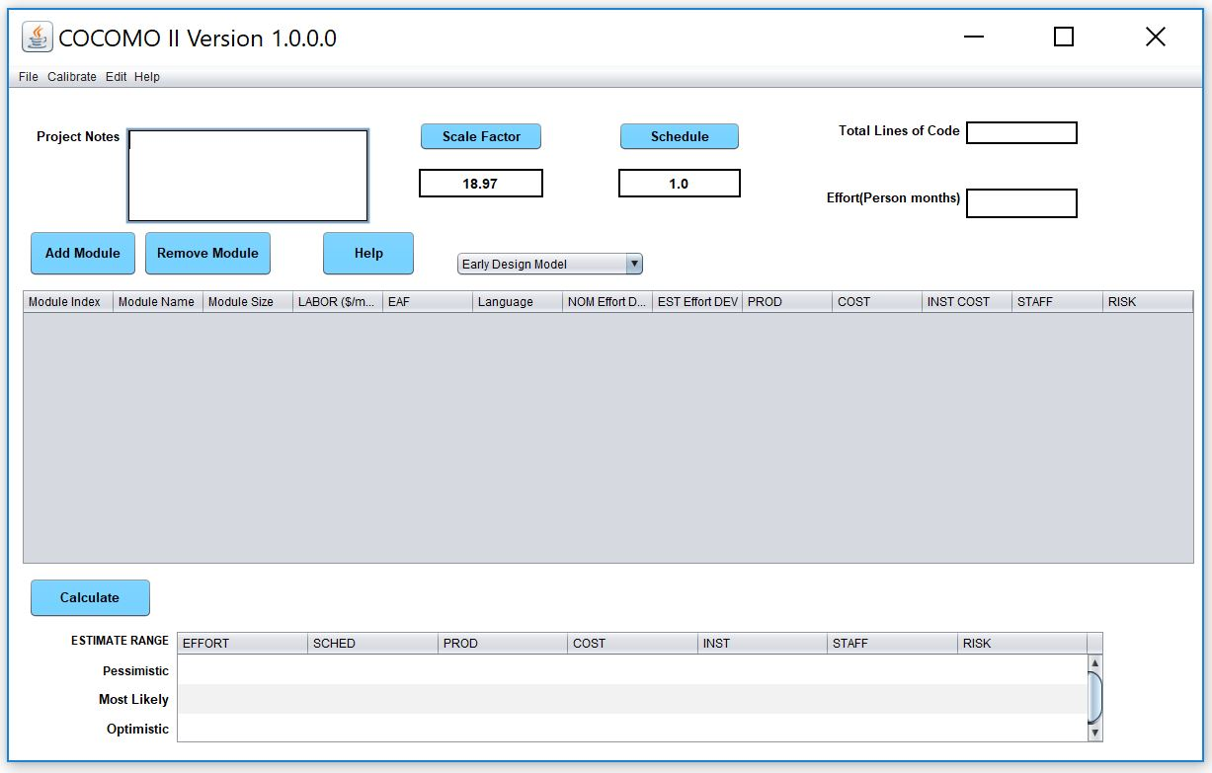

4. X - This column is reserved for identifying a module. Pressing upon this field for a given module will mark the desired module. Marking is denoted by an x that appears in this column. Only one module can be marked at a time. Modules are marked in order to perform module deletion, cutting, copying or pasting.
5. Module Name Column - This column is used to house the name of each module located in the Module Area. The module name can be changed by clicking twice on the desired module name box and entering the changes into the module name field. Upon completion of editing press "Return".
6. Module Size (SLOC) Column - This column is used to house the SLOC of each module located in the Module Area. The value for SLOC can be computed in one of three ways. One, the value can be entered directly in the SLOC field as shown in Figure 1-4. Two, by using the function point model as shown in Figure 1-5. Three, by using Adaptation Adjustment Factor as shown in Figure 1-6. Upon completion click on OK. There is a limit to the range of input. The inputted value for SLOC must be within the range 0 - 9,999,999.
Note - COCOMO is not calibrated for Total SLOC < 2000.

FIGURE 1-4 SLOC Dialog Box - Source Lines of Code (SLOC)

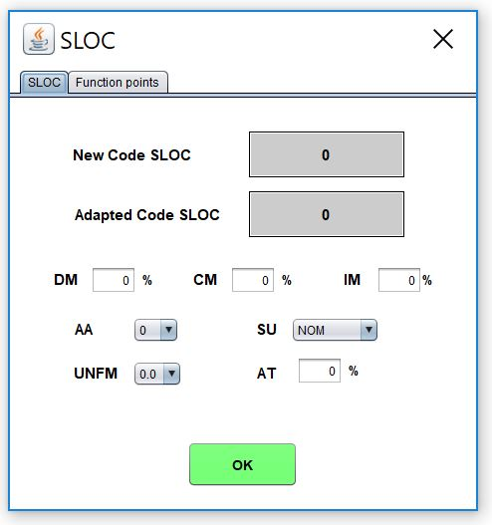
FIGURE 1-5 SLOC Dialog Box - Function Points (FP)
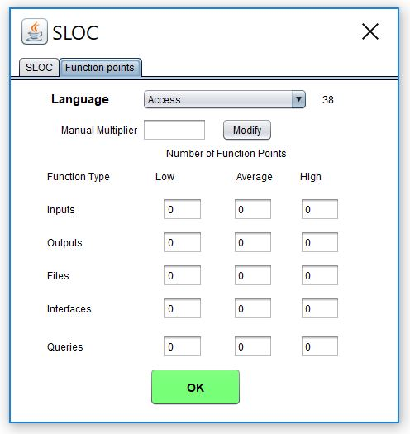

FIGURE 1-6 SLOC Dialog Box - Adaptation Adjustment Factor (AAF)

7. Labor Rate Column - This column contains the amount of money at which a developer working on a particular module would be paid per month. The labor rate can be edited by clicking on the corresponding Labor Rate box and entering the new value via the edit area. The range on labor rate is between $0 and $99,999.
8. Effort Adjustment Factor (EAF) Column - This column displays the product of the cost drivers for each specific module. By clicking on this field a dialog box appears (see Figure 1-7). This box displays all of the cost drivers, inter cost drivers and their current ratings. The cost drivers are divided into the groupings: Product, Platform, Personnel and Project. The inter cost drivers are rated as 0%, 25%, 50%, and 75 %. The ratings for each multiplier can be changed by cycling through the available ratings until the desired rating is displayed. As the cost driver ratings are changed the total product of the cost drivers is displayed in the upper right hand corner of the dialog box along with the module name. The final rating of a cost driver is calculated using this formula for the interpolation.
Final rating = (Next cost driver rating - Current cost driver rating) * Current inter cost driver / 100
9. Totals Area - This area houses the calculated results of all of the modules combined. Within this area is the total SLOC count for the module, the total nominal effort (PM), the total nominal productivity (SLOC/PM), the total estimated effort (EST PM), the total estimated productivity (Prod), the total estimated project cost, the estimated cost per instruction, the total estimated FSWP and the total estimated schedule for project completion (see each individual column for more information). The latter six quantities have not only a most likely estimate but also an optimistic estimate (no less than this, 90% of the time) and a pessimistic estimate (no greater than this, 90% of the time).
10. Status bar - This window displays a short definition of the column headings clicked upon and also displays a short description of the result of the last function initiated by the user.
11. Schedule Button - This button displays the Schedule Dialog Box as shown in Figure 1-8.
12. Scale Factor Button - This button displays the Scale Factor Dialog Box as shown in Figure 1-9.
13. Risk Column - This column contains the Total risk level for each specific module. This box displays all of the risk levels for the chosen module. The total risk of a module is computed as:
total_risk=schedule_risk+product_risk+personnel_risk+process_risk+platform_risk+reuse_risk;
total risk of a module=total_risk/373.*100.;
For the definitions of schedule risk, product risk, platform risk, personnel risk, process risk, and reuse risk, see [Madachy 1997].
14. Full-time Software Personnel (FSWP) Column - This column houses the calculated most likely estimate for the number of full-time developers that would be needed to complete a module in the estimated development time.
15. Instruction Cost Column - This column contains the calculated most likely cost per instruction. This number is calculated from Cost/SLOC in each module.

FIGURE 1-7 EAF Dialog Box

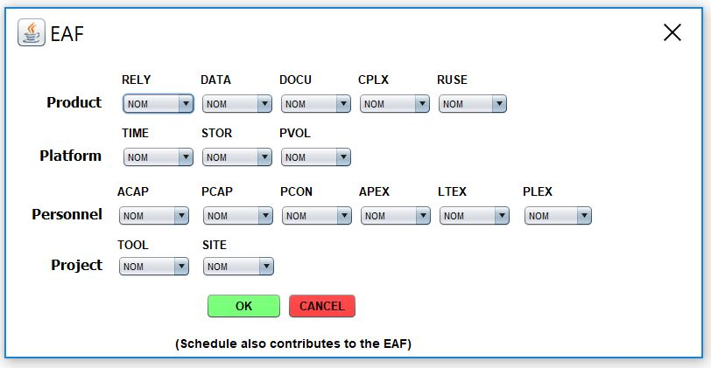

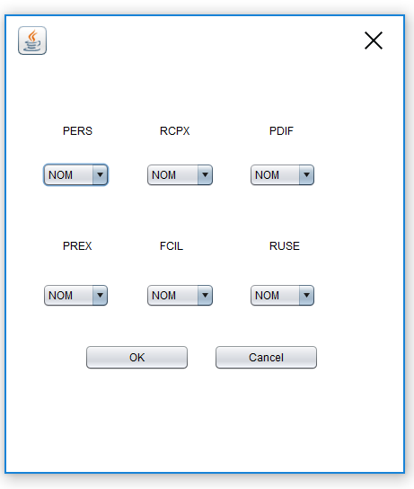

FIGURE 1-8 Schedule Dialog Box

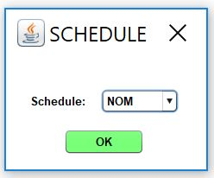

16. Cost Column - This column contains the calculated most likely estimate of the development cost for a particular module.
17. Productivity (PROD) Column - This column contains the calculated result of the module’s individual SLOC divided by the module’s most likely effort estimate.
18. Estimated Person-Month (EST PM) Column - This column holds the module’s most likely effort estimate obtained from multiplying Effort Adjustment Factor (EAF) by Nominal Person Month (NOM PM).
19. Nominal Person-Month (NOM PM) Column - This column holds the module’s most likely effort estimate without incorporating the Effort Adjustment Factors (EAF).

FIGURE 1-9 Scale Factor Dialog Box

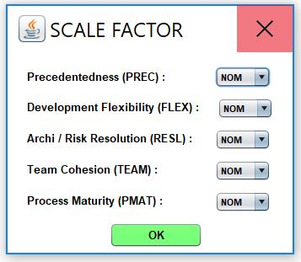

1.3 Begin Using COCOMO
To begin entering a new module, either click on the "Add Module" button on the Tool bar or on the pulldown menu item (Edit|Add Module). At this point, a new module will appear in the CLEF with all values set to their respective defaults. Double click upon the module name field in order to give the new module a name. Upon typing the module name press "Return.". A value for SLOC and Labor rate may also be given by clicking on the respective field and editing appropriately (see Figure 1-11).

FIGURE 1-11 Create Sample Module and give values to SLOC and Labor Rate

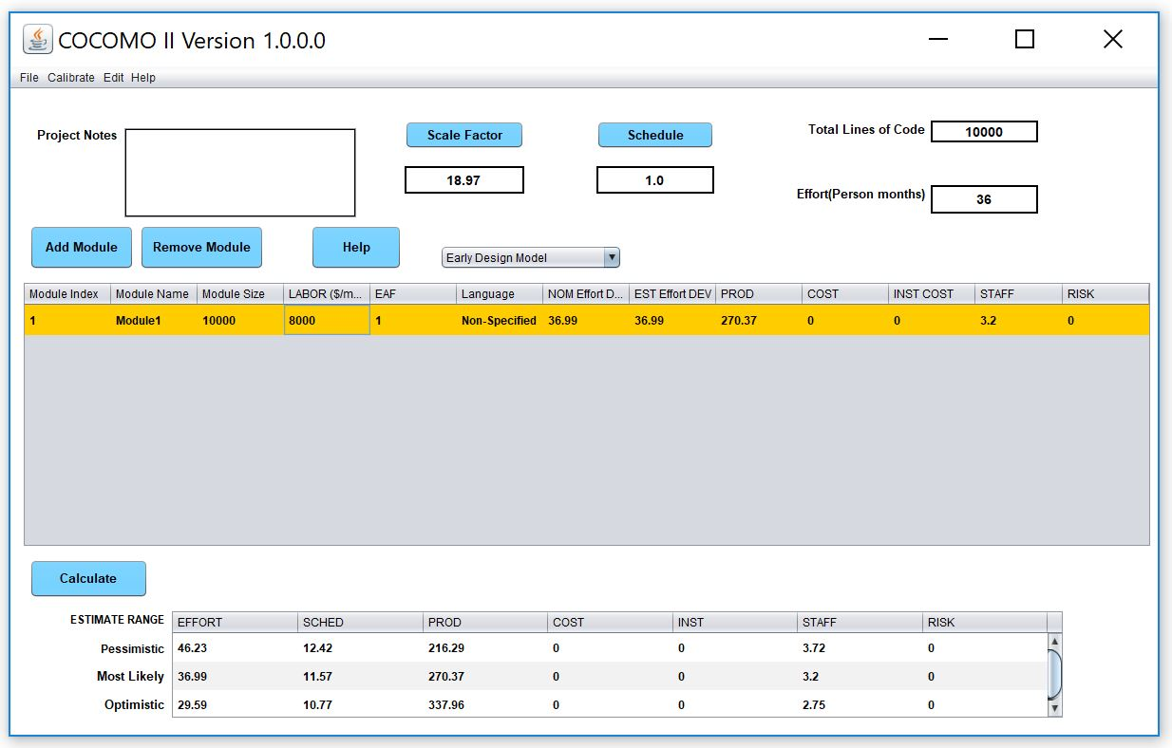

NOTE - In order to change any of the editable fields, just click on the desired field twice and begin editing the field. Upon completing editing, either hit the "Return" key, or click on OK. All of the final results can be found at the bottom of the CLEF in the Totals area (see Figure 1-12).

Chapter 2: File Menu

The COCOMO file types include: project file, model file, report file, calibration file, and csv file. The first three are discussed here. The others are discussed in later chapters.
The project file in COCOMO stores a project’s data, which include project name, project scale factors, project schedule constraint, module name, SLOC, labor rate, effort adjustment factors (EAF), and COCOMO related calculation results. The COCOMO system gives all project files an ".est" extension.
Regarding the model file, as we mentioned in chapter one, COCOMO incorporates 17 predictor factors, or cost driver attributes, which are grouped into four categories: software product attributes, platform attributes, personnel attributes, and project attributes. Each of these cost drivers attributes determines a multiplying factor, which estimates the effect of the attribute in software development effort. There are also two user defined EAF factors plus the project-level required development schedule EAF factor. Besides these cost drivers, COCOMO also has scale factors. These multiplying factors and effort estimating equations constitute the model of a project. As we said previously, COCOMO has assigned default values and equations for the annually calibrated default model. Each time a COCOMO project is created, its effort estimate is based on the default model. COCOMO provides flexibility in changing the values of multiplying factors and effort estimating equation, or schedule estimating equation. An adjusted model can no longer be considered default values, and therefore it will be lost if COCOMO is exited without saving it in a model file. Upon saving this model file, these altered values can be applied to another project by loading the saved model file. The COCOMO system gives all model files a ".mod" extension.
The report file is a summary report of the COCOMO project. This report contains all entered and calculated values of a project. These files are given a ".rpt" extension.
The File menu option will enable you to create, retrieve, save, or print COCOMO files.
To select the File menu and its options, click on File with the mouse. The File menu will appear as Figure 2-1.

FIGURE 2-1 File Menu

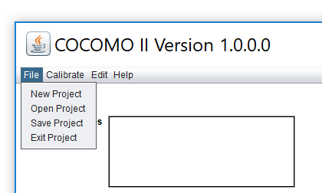

2.1 New

The New option creates a new project file in the COCOMO working window, replacing any previous project file in the working window.
To Create a New Working File
1. Choose New from the File menu with mouse.
The working window will now be clear; the previous project file in the working window has been removed.
Note: New can be selected anytime; however, if the previous project file or model file has been modified, a warning dialog box will appear and requests confirmation. (as seen in Figure 2-2)

FIGURE 2-2 Warning Dialog Box

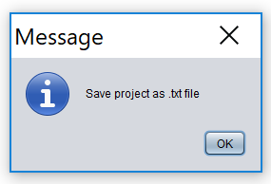

2. If the modifications on the previous file are not to be saved, choose Yes, otherwise choose No. If the No is selected, a Save File dialog will appear. (See Save Project and Save Model respectively)

Load Project

The Load Project option is used to retrieve a project file as well as loading it on the working window.
To Retrieve or Load a Project File
1. Choose Load Project from the File menu with the mouse.
2. If the previous project file is to be saved, choose Yes, then a Save File dialog box will appear. (See Save Project). If the modified file is not to be saved, choose No.
3. The Load Project dialog box will appear as seen in Figure 2-4.

FIGURE 2-4 Load Project Dialog Box

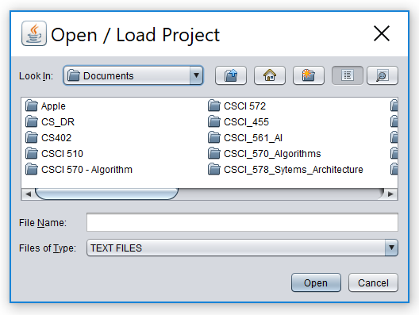
The file name of a COCOMO project has a default format with ".est" as an extension. With this window, the desired project file can be selected from the Files scroll list for loading. If the desired project file does not exist in the scroll list, it is necessary to choose an appropriate directory.
5. Choose desired directory for file loading
6. When the desired file is shown on the Files list, click it, and click the "OK" button to initiate project loading.
7. After a project file is loaded, its file name will be displayed on the PROJECT FILE field at upper left corner on the working window, and all modules and related items will be displayed in the CLEF area. If the number of modules is beyond the window scope, the scroll bar can be used to look at all items.

2.3 Save Project

The Save Project option is used to store the results of the current COCOMO project as a file with ".est" extension.

To Store the Results of Current Project
1. Choose Save Project from the File menu with the mouse. If the current project is loaded from a previously stored project file, the Save Project will overwrite the same project file with the current project.
2. If the current project is a new one, i.e., being created by the New command, the Project Save dialog box will appear, as seen in Figure 2-5.
FIGURE 2-5 Save Project Dialog Box

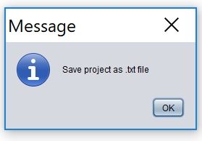

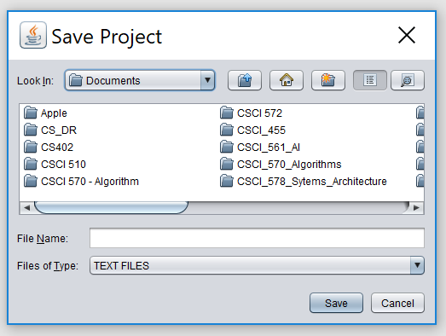
3. Look at the Files scroll window. If the file saving is to update (overwrite) a existing project file, the desired filename should be found in the Files scroll list. If the filename cannot be found from current list, change the directory from the Directories scroll list until the desired filename is being shown. When the desired filename is on the list, click it.
4. If the file saving is to store a new project file, choose the desired directory, then type in a new filename.
5. After the desired filename is selected or inputted, click the OK button to initiate project saving.

2.4 Save As Project

The Save As Project option is to store the current project as a COCOMO project file, which has a file name different from current file.

To Store Current Project with different File Name

1. Choose Save As Project from the File menu with the mouse.
2. The Save Project dialog box will appear, as seen in Figure 2-6.

FIGURE 2-6 Save Project Dialog Box

3. Look at the Files scroll window. If the file saving is to update (overwrite) a existing project file, the desired filename should be found in the Files scroll list. If the filename can not be found from current list, change the directory from the Directories scroll list until the desired filename is being shown. When the desired filename is on the list, click it.
4. If the file saving is to store a new project file, choose the desired directory, then type in a new filename in the SELECTION box.
5. After the desired filename is selected or inputted, click the OK button to initiate project saving. After a project file is saved, the project file name will be displayed on the PROJECT FILE field at the upper left corner of the working window.

2.5 Load Model
The Load Model command is used when a specific model, in which the values of multiplying factors and scale factors are different from the COCOMO default model, is to be applied to the current project.
The Load Model option is used to retrieve a model file as well as loading it for the current project.
To Retrieve or Load a Model File
1. Choose Load Model from the File menu.
2. If a previous model has been modified in the current project, the following dialog box will appear.

FIGURE 2-7 Warning Dialog Box

3. If the previous model file is to be saved, choose Yes, then a Save Model dialog box will appear. (See Save Model). If the modified model is not to be saved, choose No.
4. The Load Model dialog box will appear as seen in Figure 2-8.

FIGURE 2-8 Load Model Dialog Box

The file name of a COCOMO model has a default format with ".mod" as an extension. With this window, the desired model file can be selected from the Files scroll list for loading. If the desired model file does not exist in the scroll list, look for it in the other directories.
5. Choose desired directory for file loading
6. When the desired file is shown on the Files list, click it, and click the "OK" button to initiate model loading.
7. After a model file is loaded, its file name will be displayed on the MODEL FILE field at upper left corner on the working window, and the related costs of current project will be recalculated and shown on the working window.

2.6 Save Model

The Save Model option is used to store the results of the current COCOMO model as a file with ".mod" extension.
To Store the Results of Current Model
1. Choose Save Model from the File menu. If the current model is loaded from a previously stored model file, the Save Model will overwrite the same model file with the current model.
2. If the current model is a new one, the Save Model dialog box will appear, as seen in Figure 2-9.

FIGURE 2-9 Save Model Dialog Box

3. Look at the Files scroll window. If the file saving is to update (overwrite) a existing model file, the desired filename should be found in the Files scroll list. If the filename can not be found from current list, change the directory from the Directories scroll list until the desired filename is being shown. When the desired filename is on the list, click it.
4. If the file saving is to store a new model file, choose the desired directory, then type in the filename.
5. After the desired filename is selected or inputted, click the OK button to initiate model saving.

2.7 Save As Model

The Save As Model option is to store the current model as a COCOMO model file, which has a file name different from current model.
To Store Current Model With different File Name
1. Choose Save As Model from the File menu.
2. The Save Model dialog box will appear, as seen in Figure 2-10.

FIGURE 2-10 Save As Model Dialog Box

3. Look at the Files scroll window. If the file saving is to update (overwrite) a existing model file, the desired filename should be found in the Files scroll list. If the filename can not be found from current list, change the directory from the Directories scroll list until the desired filename is being shown. When the desired filename is on the list, click it.
4. If the file saving is to store a new model file, choose the desired directory, then type in the filename in the SELECTION box.
5. After the desired filename is selected or inputted, click the OK button to initiate model saving. After a model file is saved, the project file name will be displayed on the MODEL FILE field at the upper left corner of the working window.

2.8 Make Report
The Make Report option creates a COCOMO report in the form of a text file for printing.

To Create Project Report
1. Choose Make Report from the File menu.
2. The Make Report dialog box will appear, as seen in Figure 2-11.

FIGURE 2-11 Make Report Dialog Box

NOT APPLICABLE.

3. Look at the Files scroll window. If the file saving is to update (overwrite) a existing report file, the desired filename should be found in the Files scroll list. If the filename can not be found from current list, change the directory from the Directories scroll list until the desired filename is shown. When the desired filename is on the list, click it.
4. If the file saving is to store a new report file, choose the desired directory, then type in the filename.
5. Choose desired directory for file saving: Look at the filter input box. The path found in this box represents the directory where the report file is going to be saved. This path will be changed after each directory change. To change the directory, click the appropriate directory choice from the Directories scroll list, then click the "Filter" button.
6. After the desired filename is selected or inputted, click the OK button to initiate report file saving.
7. To print a COCOMO project report, execute the local commands for your system in order to send the file for printing.

Export

The Export option lets you select a directory to write files that can be imported into Excel.

To Export
1. Choose Export from the File menu.
2. The Export dialog box will appear, as seen in Figure 2-12.

Figure 2-12 File Export Dialog Box

NOT APPLICABLE.

3. When you click on OK, a dialog box appears if Main.csv and Phases.csv already exist, as shown in Figure 2-13.

Figure 2-13 Subsequent File Export Dialog Box

NOT APPLICABLE.

4. If Yes is selected, COCOMO saves two files(main.csv and phase.csv) in the chosen directory.
If No is selected, these files will not be replaced.

Save Screens

The Save Screens option allows the user to save the image of any Cocomo window.

To Save Screens
1. Choose Save Screens from the File menu.
2. The Save Screens dialog box will appear, as seen in Figure 2-14.
3. Follow the directions on the dialog box.

Figure 2-14 Save Screens Dialog Box

NOT APPLICABLE.

2.11 Print Screen

The Print Screen option prints the screen of the main Cocomo window.

To Print Screen
1. Choose Print Screen from the File menu.
2. The Print Screen dialog box will appear, as seen in Figure 2-15.

Figure 2-15 Print Screen Dialog Box

NOT APPLICABLE.

3. The Name of the printer can be selected from the dropdown list. Alternatively, you can print to a file by clicking on the Print to file checkbox.
4. Properties of the printer can be set by clicking on the Properties button.
5. The Print range can be All or Pages (e.g. from 1 to 3).
6. The Number of copies can be selected by clicking the up and down arrows, or by typing a number directly.
7. Select OK when finished to print or select Cancel to not print.

2.11 Print Preview

The Print Preview option displays that which will appear when printed, if Print Screen is selected from the File menu.

To Preview what is to be printed
1. Choose Print Preview from the File menu.
2. The Print Preview dialog box will appear, as seen in Figure 2-16.

Figure 2-16 Print Preview Dialog Box

NOT APPLICABLE.

- Select the Print button to print.
- The Next Page button to advance to the next Page.
- The Zoom In button zooms in, and the Zoom Out button becomes enabled so that the user can zoom out.
- The Close button closes the Print Preview dialog.

2.12 Print Setup

The Print Setup option allows the user to set up printing.

To set up Printing
1. Choose Print Setup from the File menu.
2. The Print Setup dialog box will appear, as seen in Figure 2-17.

Figure 2-17 Print Setup Dialog Box
NOT APPLICABLE.

3. The Name of the printer can be selected from the dropdown list.
4. Properties of the printer can be set by clicking on the Properties button.
5. The Size and Source of the paper can be selected from the dropdown lists.
6. The Network button can be selected to connect to a printer on a network.
- Select OK when finished to print or select Cancel to not print.

2.13 Exit

The Exit option leaves the COCOMO system.
To Exit COCOMO
1. Choose Exit from the File menu with the mouse.
2. This causes your system to terminate the cocomo program.

Chapter 3: Edit Menu
The Edit Menu option supplies several useful commands, which will enable you to establish a project more conveniently.
To select the Edit menu and its options, click on Edit with the mouse, then the Edit menu will appear as Figure 3-1.
FIGURE 3-1 Edit Menu

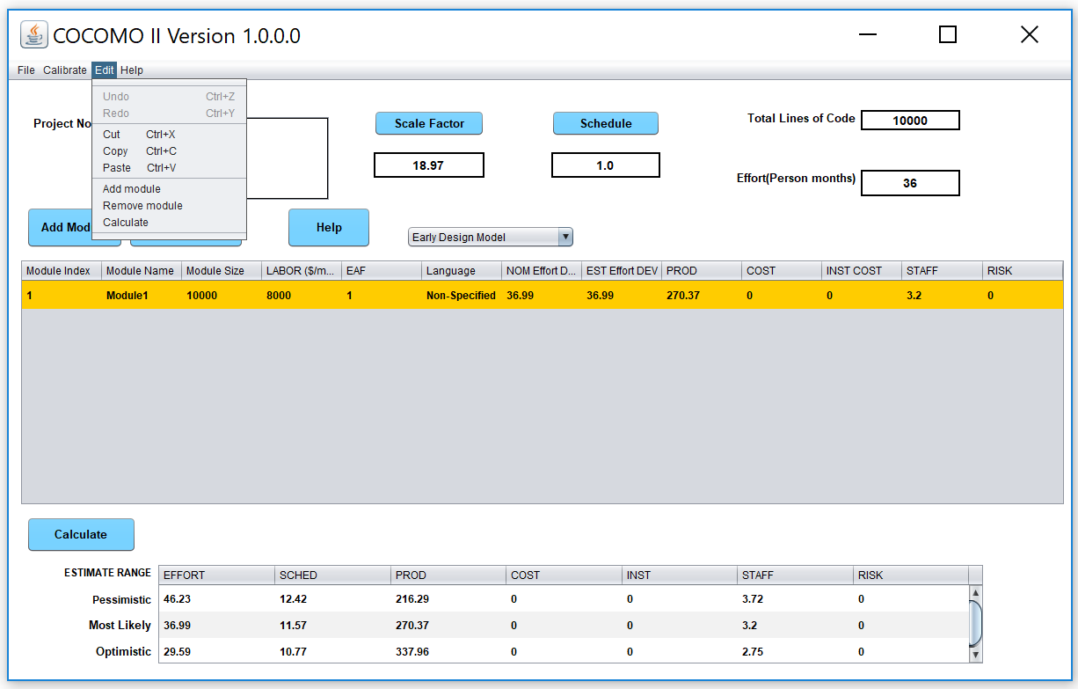

Add Module

The Add Module option adds a new module to the project that is currently being worked upon by the user. This Add Module function can be done by pressing the Add Module button in the Tool bar area.

3.2 Undo
The Undo option retracts the previous cut or paste done on a module.
To Retract Previous Cut/Paste for a Module
1. Choose Undo from the Edit menu with the mouse.
2. The changed module will go back to its previous status.

3.3 Cut
The Cut option copies a module into the cut buffer and removes it from the current project. The cut module can be used for Paste.
To Cut a Module and Remove It From the CLEF
1. Check the module which is to be cut. The Check boxes for modules are located in the leftmost column of the CLEF area. Place the mouse in the box just to the left of the module name, and click.
2. Choose Cut from the Edit menu with the mouse.
3. The cut module disappears.

3.4 Copy
The Copy option copies a module. The copied module can be used for Paste.
To Copy a Module
1. Check the module which is to be copied. The Check boxes for modules are located in the leftmost column of the CLEF area.
2. Choose Copy from the Edit menu with the mouse.
3. The cross sign in the check box disappears.

3.5 Paste
The Paste option pastes a previously copied or cut module in the CLEF.
To Paste a Previously Copied or Cut Module
1. Check the module above which the previously copied or cut module is to be pasted. The Check boxes for modules are located in the leftmost column of CLEF area.
2. Choose Paste from the Edit menu with the mouse.
3. The pasted module appears at the checked position, and the modules lower than it were pushed one row down.
4. If there is no module checked, the Paste will attach the previously copied or cut module at the end.

Chapter 4: Form Menu
The Form menu option will enable you to look at, or change the values of effort adjustment factors, scale factors and effort/schedule estimating equations factors for the current project.
To choose the Form menu and its options, click on Form with the mouse.

4.1 Product
The Product option displays five cost drivers: RELY, DATA, DOCU, CPLX, and RUSE and their corresponding ratings and multiplier values.
Select Product from the Parameters menu with the mouse. The Product Dialog Box will appear as Figure 4-2.

FIGURE 4-2 Product Dialog Box

To modify these values, go straight to those edit boxes and type new values. When finished with the modification, click the OK button.

4.3 Personnel
The Personnel option displays six cost drivers: ACAP, AEXP, PCAP, PEXP, LEXP, and PCON and their corresponding ratings and multiplier values.
Select Personnel from the Parameters menu with the mouse. The Personnel Dialog Box will appear as Figure 4-4.

FIGURE 4-4 Personnel Dialog Box

To modify these values, go straight to those edit boxes and type new values. When finished with the modification, click the OK button.

4.4 Project
The Project option displays three cost drivers: TOOL, SCED, and SITE and their corresponding ratings and multiplier values.
Select Project from the Parameters menu with the mouse. The Project Dialog Box will appear as Figure 4-5.

FIGURE 4-5 Project Dialog Box

To modify these values, go straight to those edit boxes and type new values. When finished with the modification, click the OK button.

User Defined EAF

The User Defined EAF option displays two cost driver: USR1 and USR2, and their corresponding ratings and multipliers.
Select User EAF from the Parameters menu with the mouse. The User EAF Dialog Box will appear as Figure 4-6.
FIGURE 4-6 User Defined EAF Dialog Box

NOT APPLICABLE.

To modify these values, go straight to those edit boxes and type new values. When finished with the modification, click the OK button.

Scale Factors

The Scale Factors option displays five development attributes: PREC, FLEX, RESL, TEAM and PMAT, and their corresponding ratings and values.
Select Scale Factors from the Parameters menu with the mouse. The Scale Factor Dialog Box will appear as Figure 4-7

FIGURE 4-7 Scale Factors Dialog Box

To modify these values, go straight to those edit boxes and type new values. When finished with the modification, click OK button.

4.7 Equation
The Equation option displays effort and schedule equations. Select Equation from the Parameters menu with the mouse. The Equation Dialog Box will appear as Figure 4-8.

FIGURE 4-8 Equation Dialog Box
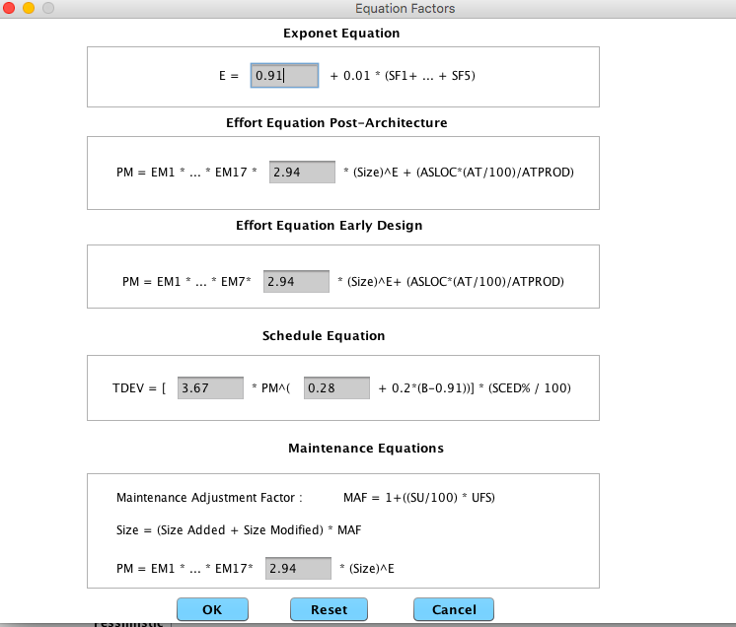
To modify these values, go straight to those edit boxes and type new values. When finished with the modification, click the OK button.

4.8 Reset
The Reset option resets the values of multiplying factors and effort/schedule estimating equations of the current project back to the COCOMO default values.
Select Reset from the Parameters menu with mouse. The command will be executed directly, and there is no warning message for users. After the RESET, the values of all multiplying factors and effort estimating equations of current project will be changed to the COCOMO default values.

Chapter 7: Maintenance
Maintenance is one of the menu selections in the menu bar that can be accessed by clicking upon "Maintenance" in the menu bar. Its function is to calculate and display an estimate of the effort and cost necessary to maintain a post development software product for a user-defined number of years (maximum five years). Maintenance encompasses the process of modifying existing operational software while leaving its primary functions intact. This process excludes the following types of activities:
■ Major re-design and re-development (more than 50% new code) of a new software product performing substantially the same functions
■ Design and development of a sizeable (more than 20% of the source instructions comprising the existing product) interfacing software package which requires relatively little redesigning of the existing product
■ Data processing system operations, data entry, and modification of values in the database
Maintenance does include the following types of activities:
■ Re-design and re-development of small portions of an existing software product
■ Design and development of small interfacing software packages, which require some redesign of the existing software product
■ Modification of the software product's code, documentation, or database structure
Maintenance effort and costs are determined by essentially the same cost driver attributes used to determine the software development costs and effort (exceptions are the RELY, SCED and MODP factors which will be discussed in greater detail later in this chapter). The maintenance calculations are heavily based upon the Maintenance change Factor (MCF) and the Maintenance Adjustment Factor (MAF). The MCF is similar to the Annual change Traffic in COCOMO81, except that maintenance periods other than a year can be used (see EQ 7-1).
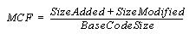
Maintenance Change Factor (EQ 7-1)

The initial maintenance size is obtained in one to two ways. The first equation in EQ 7-2 is used when the base code size is known and percentage of change to the base code is known. The second equation in EQ 7-2 is used when the fraction of code added or modified to the existing base code during the maintenance period is known.
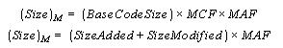
Initial Maintenance Size(EQ 7-2)

As shown in EQ 7-2, the initial maintenance size estimate is adjusted with a Maintenance Adjustment Factor (see EQ 7-3).
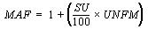
Maintenance Adjustment Factor(EQ 7-3)
The resulting maintenance effort estimation formula is the same as the COCOMOII Post Architecture development model (see EQ 7-4).
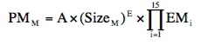 Maintenance Effort (EQ 7-4)
As stated previously, three cost drivers for maintenance differ from development. Those cost drivers are software reliability (RELY), modern programming practices (MODP) and schedule (SCED). The reason for the change in MODP, RELY is that increased investment in software reliability and use of modern programming practices during software development have a strong positive effect upon the maintenance stage. The SCED attribute is controlled by the number of years value entered by the user. As a result, the SCED driver is no longer editable in the EAF window, but is calculated from the user inputted value for number of years when the maintenance function is engaged. For more information on these cost drivers please refer to the introduction of this manual.
The Maintenance menu option offers sub-menu for either a maintenance effort estimation upon either an entire project or an individual module (see Figure 7-1). These separate options are discussed in section 7.1 and 7.2.
FIGURE 7-1 Maintenance sub-menu

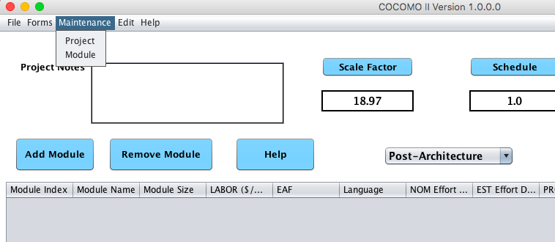

Project Maintenance

In order to view the maintenance estimation calculations for an entire project, the user can click on Project under the Maintenance menu (see Figure 7-1). Upon clicking up this selection a window will appear displaying the current project name (Module names), Development SLOC, Person month and Development cost as shown in the Figure7-2.

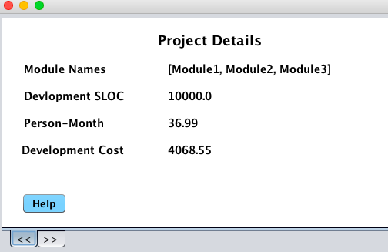
FIGURE 7-2 Project Maintenance Dialog Box .
Figure 7-3 Project Maintenance Summary
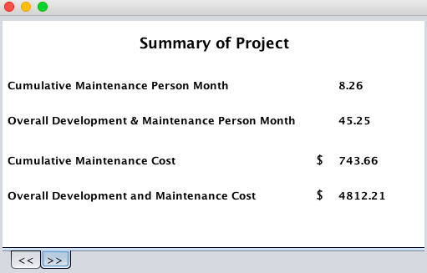
The Second page of the project is obtained by clicking in >> at the bottom of the window. This page displays the cumulative maintenance person month, overall development and maintenance person month, cumulative maintenance cost and overall development and maintenance cost (see Figure 7-3)
Note - Each individual page can be seen by cycling through the pages pressing either the Previous or Next buttons as needed.

Module Maintenance

In order to view the maintenance estimation calculations for an entire module, the user can click on Module under the Maintenance menu (see Figure 7-1). Upon clicking this section a window will appear displaying the current module names. Choose only one of the modules by highlighting the appropriate module name and then clicking upon OK (see Figure 7-8).
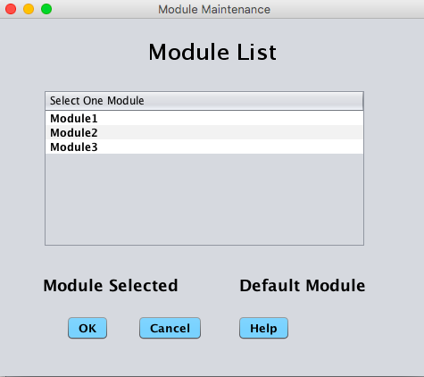
FIGURE 7-8 Module Selection window
Upon exiting the module selection window, another window will appear that displays, the selected module name, an EAF button, an editable labor rate field, editable number of years of maintenance field, an editable percent of added source instructions field per year of maintenance and an editable percent of modified source instructions field per year of maintenance (see Figure 7-9).
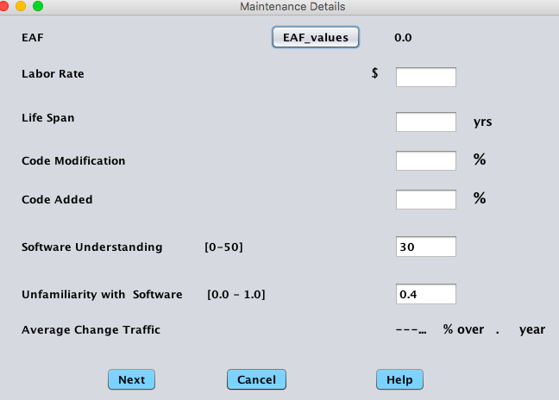
FIGURE 7-9 Module Maintenance Dialog Box

The EAF rate can be changed by clicking upon the corresponding button. This action will result in the appearance of an EAF dialog box where the cost driver ratings can be changed as described in the introduction (see Figure 7-10).
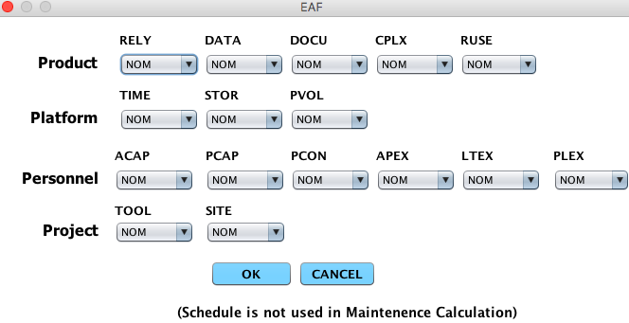
FIGURE 7-10 Module Maintenance EAF Dialog Box

Upon completing the adjustment of the cost drivers click the OK button or click the Cancel button to return to the CLEF without viewing maintenance estimations.
After exiting the EAF dialog box, you will be returned to the Module Maintenance Dialog box to continue inputting the editable values.
Click upon the OK button upon completion of editing the displayed fields or click upon the Cancel button if no changes are desired to the default values (if more assistance, the Help button is available to receive on-line assistance).
When the OK button is clicked in the Module Maintenance Dialog Box, a window displaying the first of three pages that contains the module name, the current development mode, the total number of source instructions for development of the module (EDSI) that is loaded in the CLEF, the actual effort of the module, the development cost, the inputted maintenance labor rate, the inputted percent of code added during maintenance per year, the inputted percent of code modified during maintenance per year (see figure 7-11) and the calculated annual change traffic.

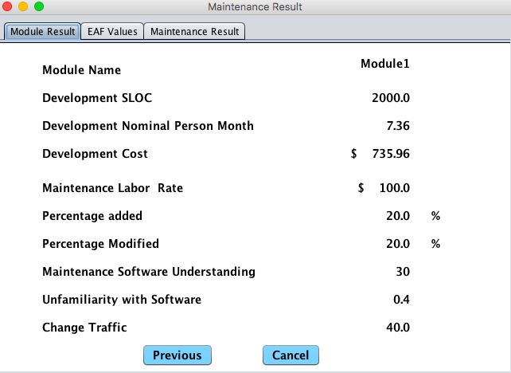
FIGURE 7-11 Module Maintenance window (page 1)

FIGURE 7-12 Module Maintenance window (page 2)
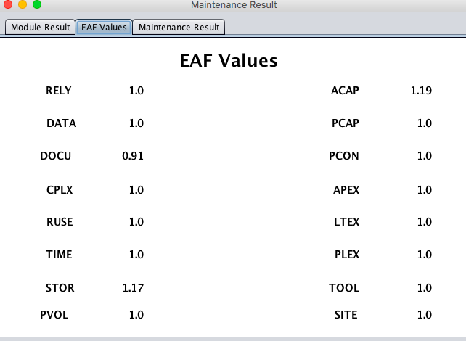
The second page of the maintenance window can be seen by switching pages to EAF Value on the top. It contains the settings for the 16 cost drivers, SCED is not applicable (see Figure 7-12).
FIGURE 7-13 Module Maintenance window (page 3)
The third page of the maintenance window can be seen by switching pages to Maintenance Result on the top. It contains the Module name, Maintenance Person Month and Maintenance cost for a particular module (see Figure 7-13).
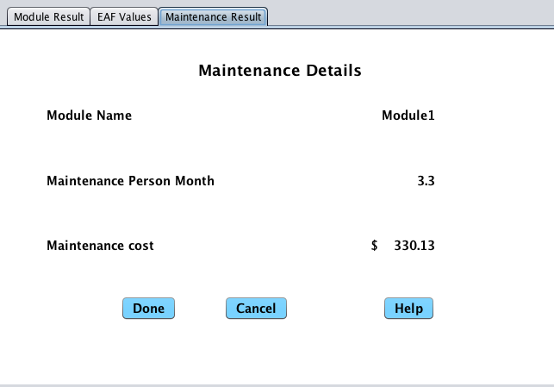
Note - Each individual page can be seen by cycling through the pages pressing either the Previous or Next buttons as needed.

Appendix A: Accelerator Keys

 | Windows
New Project | ^+N
Save Project | ^+O
Exit | ^+Q
Screenshot | ^+E
Print Screen | ^+P
Page Setup | ^+W
Edit
Undo | Ctrl+Z
Cut | Ctrl+X
Copy | Ctrl+C
Paste | Ctrl+V
Help
About USC-COCOMOII | Ctrl+H

References
Amadeus (1994), Amadeus Measurement System User’s Guide, Version 2.3a, Amadeus Software Research, Inc., Irvine, California, July 1994.
Behrens, C. (1983), "Measuring the Productivity of Computer Systems Development Activities with Function Points," IEEE Transactions on Software Engineering, November 1983.
Boehm, B. (1981), Software Engineering Economics, Prentice Hall.
Boehm, B. and W. Royce (1989), "Ada COCOMO and the Ada Process Model," Proceedings, Fifth COCOMO Users’ Group Meeting, Software Engineering Institute, Pittsburgh, PA, November 1989.
Boehm et al. (1995), "Cost Models for future Software Life Cycle Process: COCOMO 2.0", Annals of Software Engineering Special Volume on Software Process and Product Measurement, J.D Arther and S.M. Henry, Eds., J.C. Baltzer AG, Science Publishers, Amsterdam, The Netherlands, Vol 1, pp. 45 - 60.
Chidamber, S. and C. Kemerer (1994), "A Metrics Suite for Object Oriented Design," IEEE Transactions on Software Engineering, (to appear 1994).
Goethert, W., E. Bailey, M. Busby (1992), "Software Effort and Schedule Measurement: A Framework for Counting Staff Hours and Reporting Schedule Information." CMU/SEI-92-TR-21, Software Engineering Institute, Pittsburgh, PA.
IEPUG (1994), IFPUG Function Point Counting Practices: Manual Release 4.0, International Function Point Users’ Group, Westerville, OH.
Kunkler, J. (1985), "A Cooperative Industry Study on Software Development/Maintenance Productivity," Xerox Corporation, Xerox Square --- XRX2 52A, Rochester, NY 14644, Third Report, March 1985.
Madachy, J. Raymond (1997), "Heuristic Risk Assessment Using Cost Factors," IEEE Software, May/June 1997, pp. 51-59.
Park R. (1992), "Software Size Measurement: A Framework for Counting Source Statements," CMU/SEI-92-TR-20, Software Engineering Institute, Pittsburgh, PA.
Selby, R., A. Porter, D. Schimidt and J. Berney (1991), "Metric-Driven Analysis and Feedback systems for Enabling Empirically Guided Software Development," Proceedings of the Thirteenth International Conference on Software Engineering (ICSE 13), Austin, TX, May 13-16, 1991, pp. 288-298.

. % significant module interfaces specified,% significant risks eliminated.

